**Project design phase II**

**Technology Architecture**

|  |  |
| --- | --- |
| Date | 20 October 2022 |
| Team id | PNT2022TMID10587 |
| Project Name | Skill/Job Recommended application |
| Maximum Marks | 4 Marks |

**Technology Architecture:**

Project shall full fill the following information in this technology architecture .

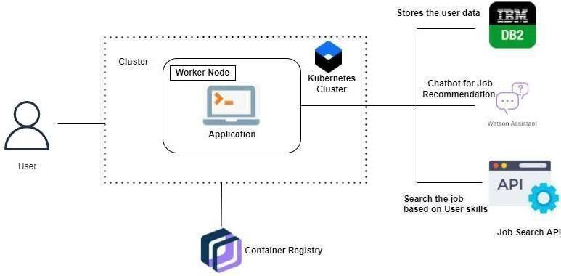

|  |  |  |
| --- | --- | --- |
| **S.No.** | **Parameter** | **Description** |
| 1. | Is the System Robust? | Yes, it is partially buildable platform as the budget required will be more as cloud is a pay per use model and time taken will be quite. |
| 2. | Is it highly modifiable? | Indeed, the framework is modifiable and it can own up to the progressions by recognizing blunders that requirements to be fixed and new functionalities. It is exceptionally receptive to the progressions. |
| 3. | Is it Scalable? | Indeed, the framework proposed is exceptionally versatile as it can deal with the developing responsibility where great execution is likewise expected to effectively work. Organization of the stage has been finished utilizing different OS virtualization stage it will deal with the responsibility genuinely. |